**Mobile Communication and Computing**

**Contact Management System**

|  |  |
| --- | --- |
| Daniel Lobo (BE CMPN A - 07) | Jenny Dcruz (BE CMPN A - 16) |

**INTRODUCTION**

The “Contact Management System” is an application that has been developed to override the problems prevailing in the obsolete manual system. This application’s features eliminate and reduce a few of the hardships faced by the existing system. No formal knowledge is needed for the user to use this system. Thus, making it easy-to-use. It’s a reliable and error free management system that is at the user’s disposal. With this Contact Management System, one has the freedom to focus on other activities rather than having to keep a record of all their contacts.

Besides automating the extant, manual telephone directory, it allows the user to store contacts for a long period of time with easy accessing and manipulation of the same. As the application is developed using Flutter, it’s compatible with both, android and ios devices of all dimensions. The main objective behind this project was to create a one-stop place for a user to store, view, edit and delete a person’s contact number, email address, and their residential address.

**COMPONENTS**

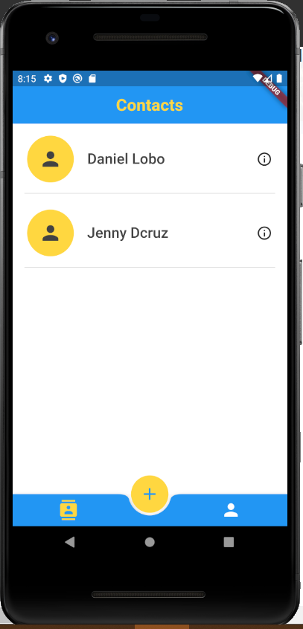

The contact management system provides a simple, yet aesthetically pleasing home page to the user that displays the names of all the existing contacts in the system. Further, it consists of the following features:

1. Adding a contact
2. Editing a contact
3. Deleting a contact
4. Contact card’s GUI
5. Maps
6. About us page
7. **Adding a contact:**

Adding a contact is the most important functionality of a contact management system. To add a contact, click on the add button in the bottom app bar. This redirects the user to the ‘Create Contact’ page wherein the name, phone number, email id and residential address can be entered to store in the device. The application validates the contact number and email address added thus making sure that incorrect data is not being entered. Upon adding a valid contact, an alert arises informing the user that the contact has been added successfully.

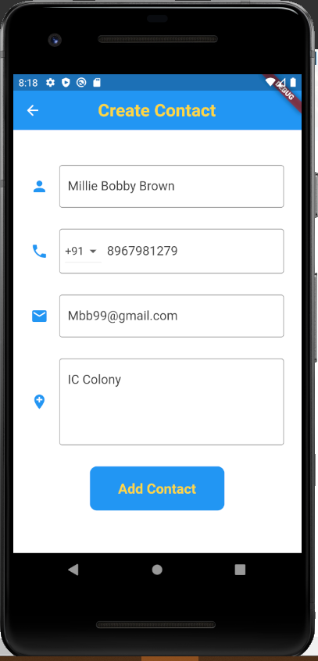 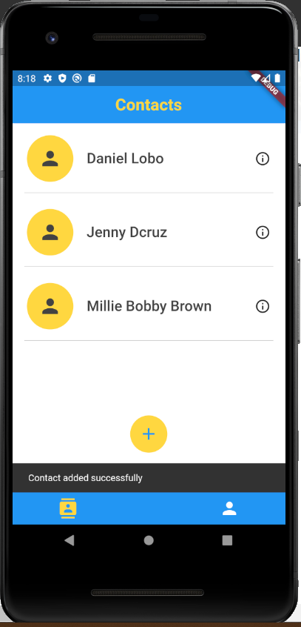

1. **Editing a contact:**

Often users tend to enter data incorrectly. It could be a tiny error or an empty field altogether. In any system the user must have the freedom or correcting the error. For this reason, our application provides an edit contact feature. To use this, one needs to simply swipe a name field on the home page, from right to left. On swiping, the user has been presented with two options: Edit or delete. When the edit option is selected, the user can edit any and every field of the contact stored. Once the edited information has been saved, it efficiently gets updated in the database and an alert arises informing the user that the contact has been updated successfully.

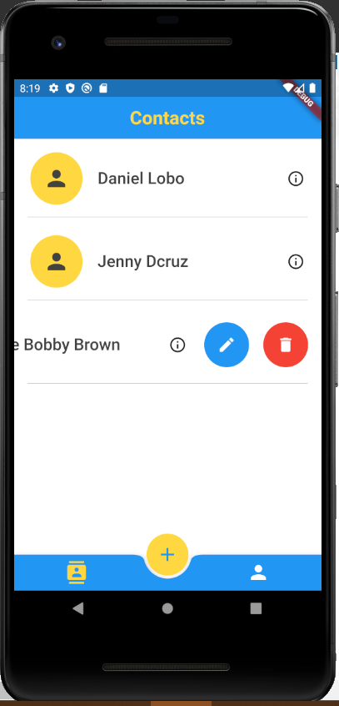 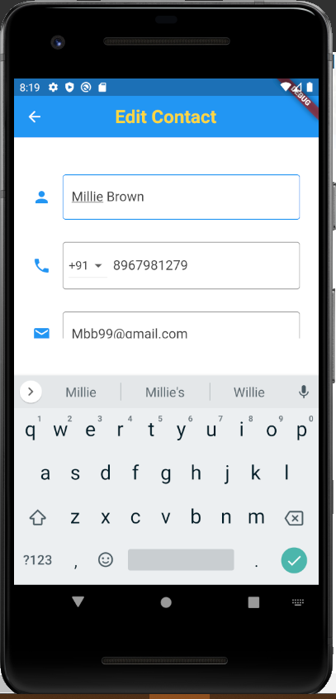 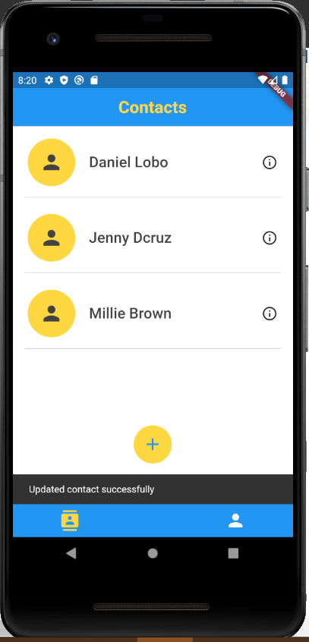

1. **Deleting a contact:**

As mentioned before, swiping a contact field in the home page provides the user with two options. If the user chooses to delete a contact, a pop up message appears in order to confirm if the user indeed wants to delete the contact. This extra step of confirmation gives the user a minute to think if they definitely want to remove this contact as once the contact details are deleted they can’t be retrieved.

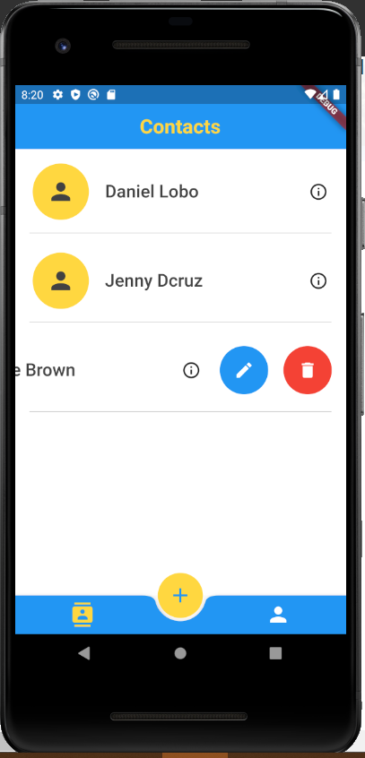 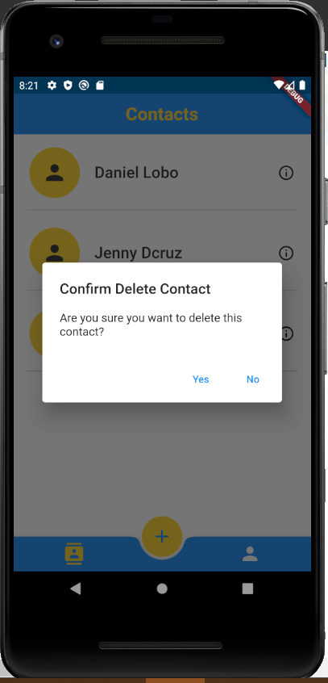 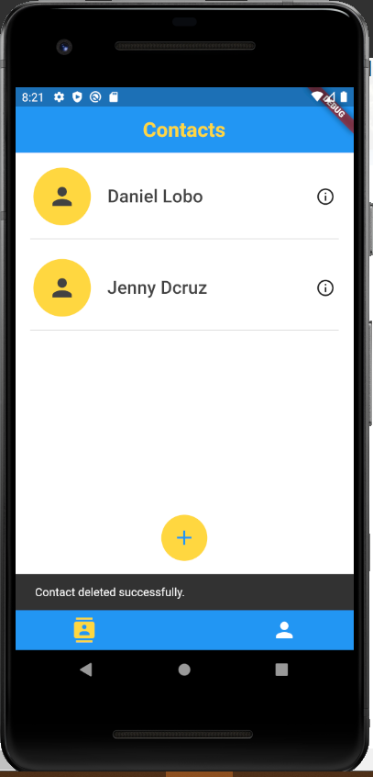

1. **Contact card’s GUI:**

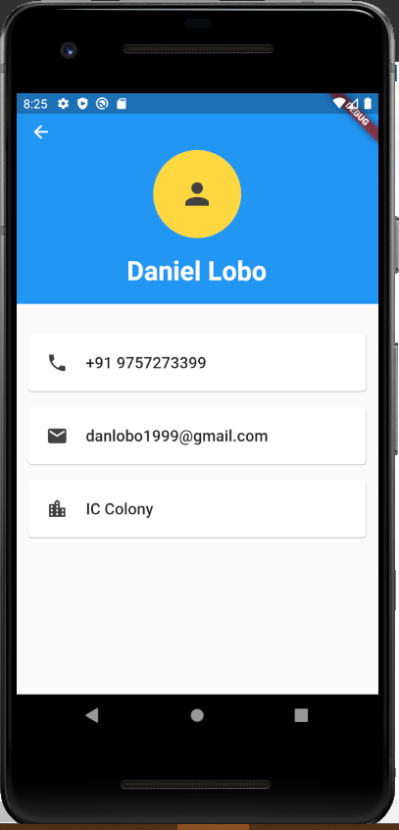

The saved contacts in the system can each be viewed individually by clicking on the contact fields in the home page. The contact card of every user displays the phone number, email address and residential address of every contact as added before.

Here, when a phone number is clicked on, the user is redirected to the keypad of the device with the number ready to dial. Similarly, clicking the email id redirects you to the default email application of your device with the selected email id already entered in the email recipients field.

1. **Maps:**

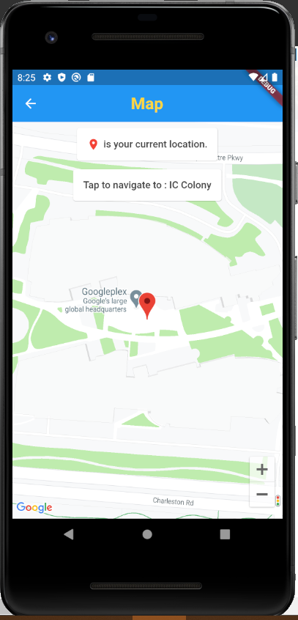

To display the location of the contact’s saved address, the application uses the Google Maps API key. The ‘Tap to navigate to:’ feature in the map opens up the google maps application with the same address loaded in the search bar. By doing so, the user gets to easily view the location of the address saved in the application and they also have the option of conveniently viewing further details preloaded in google maps.

1. **About us page:**

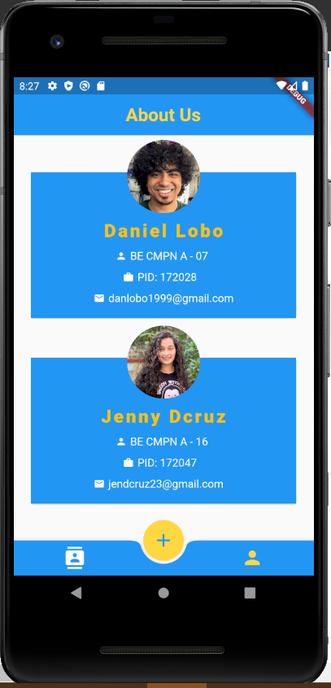

Last but not the least, the ‘About us’ page. This page displays the details of the developers of this application.

**Note: To view the code to our project on Github** [**click here**](https://github.com/jendcruz22/MCC-Proj)**.**

**CONCLUSION**

Our project is a humble venture to an efficient way of storing and managing all essential data of a contact. To implement our project, we used Flutter which is an open-source UI software development kit created by Google. As it’s open source, it is easily accessible to us and does not require a development fee. Furthermore, it conveniently reduces code development time. Most importantly, one can develop native applications for both Android and iOS using a single code base. Finally, the application created in this project has proven to be successful economically, technically, and operationally. It is feasible as it’s an error-free, cost-efficient, user friendly, and flexible application.

While the pandemic may have thrown a wrench at our academic activities, it gave us the opportunity to use Github version control and collaborate with each other on the project from home. With this experience we gained valuable insights and knowledge on developing mobile applications.